Ethernet (Solved Question 1)

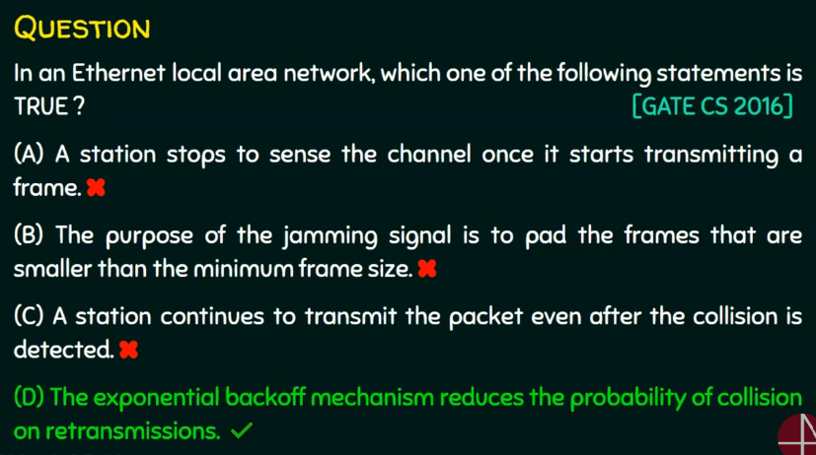

1. False. It doesnt stop
2. False. Jamming signal is to notify other stations there is a collision
3. False. If collision happens it stops sending
4. True.